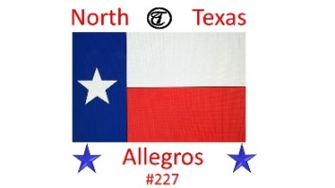

North Texas Allegros #227

New Member Application Member Renewal for Year _______

Membership Requirements

Must own a product made by Tiffin Motorhomes, Inc.

Must be a member of the International Allegro Family Motor Home Club, (Tiffin Allegro Club) with

dues current.

My Tiffin Allegro Club Membership #: **__________________ Expiration Date: **________________

Please provide the following information: RENEWALS, only ** blanks and any other changed info needed.
Driver: **_______________________________ Companion: **___________________________________
Address: _________________________________City: ________________State: ____ Zip: ____________
Driver Cell: __________________________ Companion Cell:________________________________
Driver E-mail: ____________________________ Companion E-mail: ______________________________
Number of Children under 18: _____
For Chapter Treasurer Use Only.
1. Date of Application: ___________
2. Membership Dues: $___________
($25.00 year)
4. Date Entered: ________________
Number of Grandchildren: ________
Pets Names (Dogs/Cats) ____________________________
Emergency Contact: _______________________________
Emergency Phone: ________________________________
Occupation (if Employed or Retired)
Make check payable to:
North Texas Allegros

Mail the completed application to:
Elisa Bransom
917 Woodward St
Fort Worth, TX 76107

Driver: _________________________________________
Companion: _____________________________________
Birthday, month & day (year optional)
Driver: ____________ Companion: ________________
Anniversary: (Month/Day/Year): __________________
Year & Model of Tiffin Motorhome: ______________________________
Length of Motorhome: ______ # of slides: _____How Long Rv’ing? _______________
Favorite Travel Destinations: ___________________________________________________
Hobbies/Interests:
Driver: _________________________________________________________________
Companion: ____________________________________________________________
For information visit our Facebook page- North Texas Allegros Group- 227
or our Web Site www.northtexasallegros.com

